Natural Gas in China

Martina Erhart (AT)
Karolína Sztuková (CZ)

Co-operating Universities



Financial support by

Prague and Graz, 2010
Content
1. Introduction 3
2. Abstract 3
3. Motivation 4
4. Current Situation on the Chinese Domestic Market 4
4.1 Demand 4
4.2 Supply 5
4.3 Current Price 5
5. China versus the Russian Federation 6
6. Energy mix 8
6.1 Coal as the dominant primary energy source 8
6.2 Natural gas to relief environmental pollution 9
7. Infrastructure 10
7.1 Cost considerations and geographical accessibility 10
7.2 LNG terminals satisfy growing energy demand 11
8. Gas reserves 13
8.1 Natural gas production and demand 13
9. Conclusion 15
10. Acknowledgement 16
11. References 17

1. Introduction
The People’s Republic of China is the fourth largest country in the world and with more than 1.3 billion inhabitants it is also the highest populated country worldwide. Thus, it is correct to label this country as one of the most significant players on the world market. It is clear that Chinese economic activities are able to greatly impact the world trade in nearly all industries. Our group had the opportunity to research the extent to which China affects the global market of natural gas. Besides understanding the current situation on China’s NG market, we critically reflected on chances and challenges the country meets with regards to the energy mix, NG infrastructure and reserves.
The main task of our group was to investigate the demand and supply side of natural gas in China from various aspects. Moreover, our research reveals potential challenges and opportunities of NG. Before starting to outline our results, we want to mention some essential facts that we should bear in mind when it comes to natural gas:
When we talk about boosting China’s natural gas production and consumption in order to “green up” the country, let’s not forget that natural gas is a fossil fuel as well. The carbon dioxide emissions from burning natural gas are lower than for oil and coal, but they are definitely not negligible. When we talk about saving greenhouse gas emissions by increasing the share of natural gas in China’s energy mix, let’s not forget that the mining of gas releases huge amounts of methane which is a far more potent greenhouse gas than carbon dioxide. And last but not least, when we talk about a more sustainable energy system in China, let’s not forget about the huge amount of water needed for the extraction process of natural gas. The western world might not be conscious that water actually is a scarce good. Industrial solvents are used for the extraction of gas leaving millions of gallons of polluted water behind. Let’s keep this in mind.

2. abstract
China’s position on the global natural gas market is constantly becoming stronger. We want to outline how strong China’s impact (imports, exports) is within the international trade of natural gas and how China’s NG policy might affect the market in the future.
In the second part of our paper we would like to describe the challenges that China faces regarding extraction, transfer, legal aspects and international competition of NG.
Our approach consists of both empirical data (amount of imports, exports and occurrence of natural gas) and also of a desk research from the latest publications about this topic.

3. MOTIVATION
Up to now, researchers, politics and scientists don’t know to what extent China will influence or even control the world in the future. What we know is that China is already one of the economically and socially most powerful and important countries in the world. We want to take a closer look on China’s energy situation with a special focus on the Chinese natural gas market and the complex natural gas policy.
Finally, we shall be able to estimate how strong the impact of China’s natural gas market on the world NG market actually is and how it is going to develop. Moreover, we want to give a summary about the challenges China will have to overcome.

4. Current Situation on the Chinese Domestic Market

4.1 Demand
The consumption of natural gas is rather low compared to other energy resources in China (e.g. coal) even if the consumption rises and the growth rate is increasing each year. According to research data, the consumption of natural gas rises evenly in all industries where it is used. A sharp increase of consumption has been observed especially in recent years. The largest part of natural gas consumption goes to the agricultural industry sector where it is utilized for the production of fertilizers. A sharp increase in demand is evident in large agglomerations, too. Shanghai can serve as a suitable example. The rising natural gas demand in such agglomerations is caused mainly by the government. At the moment there are no plans to access other communities in addition. In 2005 only 14% of the urban population had access to natural gas.
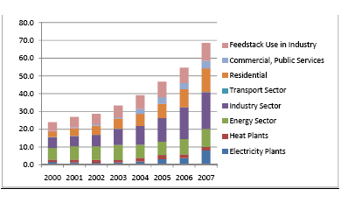
Figure 1: Natural gas consumption in China

4.2 Supply
China National Petroleum Corporation (CNPC) is the largest domestic producer of natural gas. Despite large extraction activities China is a net importer of natural gas and very likely it will continue in this position. The first contract for purchases of liquid natural gas (LNG) between China and Australia was signed in 1990. At the moment there are some other contracts, too. Selling countries to China are Indonesia, Malaysia, Qatar, and international corporations like Shell and ExxonMobil. China already holds contracts for 22,5 mtpa (30,6 bcm) which are spread over several years. The quantity of imported LNG is smaller than one tenth of Chinese annual consumption. The price of this imported LNG is already set in contracts.
China assumes growing consumption and is conscious of its inability to satisfy demand only through own resources. There are several predictions for the future Chinese demand and supply of natural gas. According to these, we can expect 40-80bcm difference between domestic demand and supply on behalf of demand.

4.3 Current Price
The key influence on this topic has the price of natural gas. The price of natural gas on the Chinese market is set by the government. There were almost no problems with it during those times when China was self-sufficient in this industry. Together with its excessive demand of natural gas problems have arisen.
The current natural gas price is determined by three groups of factors:
- “Ex-plant price” = The production costs of natural gas plus the appropriate margin for producers
- Transportation tariff = The pipeline costs plus the appropriate margin with the variation of transport distance from each gas source to each city gate
- End-user price = the distribution costs, alternative fuel prices and other market policy factors”
The first two are set by the central government and the third is set by individual provincial governments, depending on the province where the natural gas is consumed. In the last three years the Chinese government has been forced (because of increasing demand for natural gas imports) to rise the importance of the first price factor.
In 2007 and 2008, another problem came up. The contracted price of imported natural gas is derived from the world market price of oil. The oil price rose in this period which consequently caused a price increase of imported natural gas. It is likely that China will have to undergo some reform of setting the price of natural gas, which will lead to some new consumer behaviour.

5. China versus the Russian Federation
In 2007, the NG price situation led Chinese government to determine some kind of price reform. The price reform was limited to creating a paper, no realisation occurred. According to Highashi, however, there is no other way for China than “adopting the market mechanism” of setting the price.
In the 1990’s the Chinese government accepted excessive demand of natural gas and insufficient domestic supply of this good. First, China was seeking any possible import from the Russian Federation, but no contract was made between these two countries. So China directed its attention to Turkmenistan. They have contracted gas imports to China. For our analysis the price of imports is important. Higashi describes it as follows:

“One of the interpretative points is whether this agreed price is the price at the Turkmenistan border or at the Chinese border. If it is the Chinese border price, the assumed export price at Turkmenistan would be around USD 145 per 1.000 m³ because the pipeline tariff for transit countries (Uzbekistan and Kazakhstan) is estimated around USD 50 per 1.000 m³ (USD 195 - USD 50 = USD 145 per 1.000 m³). This price level was slightly higher than Russian-Turkmen export price at that time (USD 130 per 1.000 m³), but may not have been satisfying for Turkmenistan as the government insisted on increasing export prices drastically.
Another interpretation is that the agreed price of USD 195 per 1.000 m³ would indicate the Chinese border price. In this case, the Chinese border price would be USD 245 per 1.000 m³ (USD 195 + USD 50). If it is true, this price level may completely satisfy Turkmenistan while Russia may feel pressured to increase its import price from Turkmenistan.”

Here is nicely described how far prices are affected by contracts of various countries. And for example even if China and the Russian Federation did not make any contract, they affect each other via prices of gas. Another important thing arises here. If the second variant is right, it means that the price is “almost double the existing price in Shanghai”, which again put high pressure on the administratively set price. Gas from Turkmenistan is and is going to cover more than one third of the whole export to China. Therefore it is very likely that China and the Russian Federation will be indirectly affected by each other similar to what was previously described.
One possible reason why China and the Russian Federation have not yet made any contract could be that Chinese future demand of natural gas is more or less poorly predictable. This opinion is supported by some experts who claim that the Chinese future demand of natural gas will probably be not as high as it is assumed by China. (It is shown in the schedule) This is able to be one possible problem which causes that “the natural gas pipeline from Russia is not proceeding so well as the project of oil pipeline from Russia”.
“Russia is the largest and the closest gas-producing country for China. China and Russia have been both been very active in seeking natural gas deals in the very heart of Eurasia. China’s bold move to acquire Turkmen gas may apply pressure on Russia. ... Thus, the sensitive game between China and Russia is likely to continue.”
According to Highashi it is almost impossible that China and the Russian Federation could coexist in the international natural gas market with any affection to each other. The difficulty arises from uncertainty about Chinese own predictions of future demand. It is clearly seen in the following figure. This is the greatest challenge for The Russian Federation to make any deal with China.

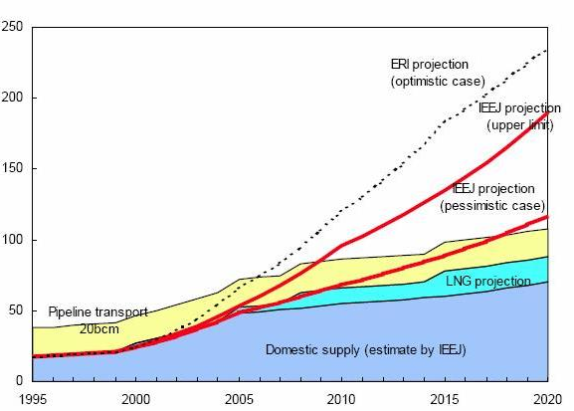
Figure 2: Gap in supply and demand of natural gas In China

Energy mix

6.1 Coal as the dominant primary energy source
Even though NG consumption has grown very fast in the last decades, the total share in the Chinese energy mix is low at about 3.5% while coal accounts for 69.5%. This is mainly due to historic development of coal use in China. Coal has led the country to massive and unprecedented growth in output which consequently has raised the standard of living for many people.
Moreover, coal has important advantages in comparison to NG: it is an easy-to-use solution for the short term in cases of primary energy shortages. It was only in November 2009 that China faced NG shortages which led to the closing of industrial facilities, office buildings and hotels in Bejing, Changsha, Nanjing and other cities. NG producers, however, didn’t have any incentive to expand the gas output because of uneconomical margins at that time. Professor Dong Xiuchen at China Petroleum University says that the root of the problem is the “natural gas price control by the government”, which doesn’t provide any motivation for the upstream side (upstream activities are: exploration, development, production; see T. Kambara/C. Howe, p. 45).
As shortcomings of oil and gas were acute difficulties in electrical supply, a new emphasis was put on coal, which can provide fast energy. This trend still continues and is supported by many “small-scale locally managed and often private mines”. Their ability to respond quickly to prices and to enlarge with only minor additional capital represents a big advantage. Nonetheless, in the long term this “handicraft” coal sector is said to be limited.
The IEA’s Natural Gas Market Review 2009 states that “both, China and India are emerging as major gas users, although their energy mixes seem certain to be dominated by coal for the foreseeable future”. Even though coal production causes heavy social and environmental burdens its use for energy supply is widely “anticipated to grow worldwide for many years”.

6.2 Natural gas to relief environmental pollution
Natural gas is said to be the “cleanest” of all fossil fuels because the emission level from its combustion is many times lower than from coal and oil. According to some educational websites of the Natural Gas Supply Association, the use of NG can help to reduce the following environmental hazards:
- Greenhouse gas emissions:
Carbon dioxide makes up the highest proportion of greenhouse gases in our atmosphere (81.2% in the US in 2000). The following table shows that NG produces about half the amount of CO₂ emissions compared to coal and about 30% less than fuel oil:
Table 1: Fossil fuel emission levels - pounds per billion btu of energy input
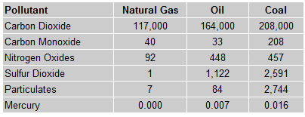
On the other side, we have to consider that methane (CH₄) is a far more potent greenhouse gas than CO₂ and it actually is the main component of NG. This fact has been a main issue in discussions whether NG is really as “clean” as many claim. A study performed by the Environmental Protection Agency and the Gas Research Institute in 1997 conciliates these discussions and concludes that the reduction in emissions from increased NG use outweighs the effects from methane by far. Still, we have to consider the prospected growth of NG use on the huge Chinese market (and in other countries) combined with the fact that methane’s global warming potential over a time horizon of 100 years is 25 times higher than it is for CO_{2.} Moreover, also the extraction, transport, liquefication and regasification of NG results in high methane emissions.
- Smog and acid rain:
Smog is formed by a chemical reaction of CO, NO_{x}, VOCs and heat. These are produced in large quantities in combustion engines, electricity power plants or industrial plants. In fact, NG emits low levels of NO_{x} when it is burnt. Thus, smog production could be reduced by 50 to 70% if the share of NG was increased in electricity generation, in vehicles and in industrial production.
Acid rain is formed when SO₂ and NO_{x} react with water vapor and other chemicals in the presence of sunlight to form acidic air compounds. As NG doesn’t emit SO₂ at all and emits up to 80 percent less NO_{x} than the combustion of coal, for instance, increased use of NG would result in fewer acid rain causing emissions.
- Industrial and electric generation emissions:
Most of the power plants in China are coal-fired and emit big amounts of SO_{2,} CO₂, NO_{x} and mercury emissions. NG-fired electric generation and NG-powered industrial applications offer various environmental benefits such as fewer emissions, reduced sludge, reburning, cogeneration and combined cycle generation.
- Pollution from the transport sector:
Air pollution from combustion engines could be reduced to a large extent by substituting gasoline, diesel or propane fuel with CNG. It has lower CO, CO₂, NO_{x} and hydrocarbon emissions of 90 to 97 percent, 25 percent, 35 to 60 percent and 50 to 75 percent respectively. [Remark: all information in this section has been taken from www.naturalgas.org]
The use and increasing the share of NG in China can reduce the environmental impacts from various sectors as described above. In spite of that, we should bear in mind that NG is not a renewable resource so it will definitely not last forever. Also we have to consider that if NG can safe emissions on the one hand, it might cause considerable harm somewhere else.

Infrastructure

7.1 Cost considerations and geographical accessibility
The first Chinese pipeline was completed in 1997, named the Ordos (Shaanxi)-Beijing Pipeline, at a length of 868 km and with a capacity of 3.6 bcm per year. After that, a huge national project was completed in December 2004, the West-East Pipeline I with a capacity of 17 bcm. At the moment, the second West-East Pipeline is being built and should be completed by 2012. The total length of the main trunk line is 4.843 km with a capacity of 30 bcm per year. The total length of the Chinese pipeline network reached about 31.000 km by the end of 2008.
For the Chinese government, it is a challenge to provide the substantial investment capital for these huge national projects. Currently, the USD 7.3 billion Asia-Chine Pipeline project is under construction and should be completed by 2015. This pipeline is planned to be financed entirely by China in order to import Turkmen gas. Details on the costly agreement between Turkmenistan and China are kept secret, however.
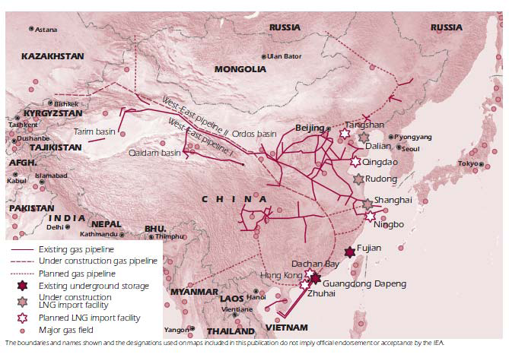
Figure 3: Natural gas infrastructure in China
Even if the ongoing infrastructural plans could be realized on time, the domestic NG doesn’t satisfy demand any longer. In 2007, the NG consumption was 69.5 bcm versus a national production of 69.2 bcm. Bearing in mind that the annual growth rate raised to more than 20% since 2004, estimates say that the gap between consumption and production will be continuously increasing, which means that China is going to be heavily dependent on NG imports.
Moreover, the location of these gas reserves (Tarim, Sichuan and Ordos basin) poses a challenge to Chinese infrastructural planning: the major gas basins are located inland, far from the main areas of demand (cities along the East and South Coast). If the gas supply for northern regions is likely to be cost-efficient, provinces along the coast will have a cost advantage by importing LNG as will be discussed later.

7.2 LNG terminals satisfy growing energy demand
As stated above, China doesn’t have a self-sufficient energy supply anymore and it is very unlikely to become so in the future. Enhanced gas imports in the form of liquefied natural gas (LNG) are becoming a candidate to solve the problem of growing energy requirements. LNG is natural gas that has been converted temporarily to a liquid form and takes up about 1/600th of the volume of NG in the gaseous state. The advantage of LNG is its ease of storage and transport so that it is much more cost-efficient over long-distance transportation than NG.
The southern seaboard and the east-coast areas are the furthest away from the NG reserves but they have the highest energy demand in China. If these regions received LNG imports from well-placed foreign sources of supply, the Chinese government could save the capital otherwise used for investments in infrastructural projects or transportation.
It has been a problem to provide sufficient energy to the southern seaboard since the 1990s. The first official authorization of plans for LNG terminal construction in April 1999 meant an important alleviation of the energy shortages. Ever since, China has constantly increased its LNG receiving capacity over several phases. The first project was completed in the southern region of Guangdong in 2006 with an annual capacity of 3 mmt of LNG. Several other LNG reception bases are under construction in the Fujian Province, in Shanghai City and other north-eastern cities.
In an integral consideration, however, we have to admit LNG’s strong impact on the CO₂ balance. The amount of CO₂ emitted per million British thermal units (lbs/106 Btu) is 20% to 40% higher than for regular natural gas. The extraction, processing, chilling, transportation and regasification make LNG a major source of greenhouse gases.
According to The Economist in an article from March 11th 2010, “China offers some hope for ambitious exporters, but even there the outlook has become cloudier” meaning that only the fastest and the cheapest suppliers will be able to make a deal with China. A run of exporters on China’s gas market has made the country pickier. The government has let some agreements expire and is now in the position to dictate prices.

Gas reserves

8.1 Natural gas production and demand
The major gas reserves in China are named the Tarim basin, Sichuan basin and the Ordos basin. They are located in the north-western and central-northern region.
Figure 4: Gas resources in China
The Tarim and Sichuan fields are thought to be by far the biggest reserves of natural gas in China, holding about 8 and 7 trillion m³ respectively, but the Ordos and other basins are very large, too, as the following table shows:
Table 2: China's major sedimentary basins: geological resources of natural gas, 1994
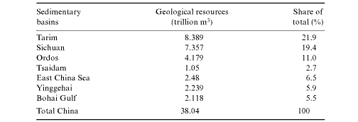
This CNPC data shows total geological resources of natural gas of 38.04 tcm. From other resources we can take different results, as for example according to Nobuyuki Higashi in the IEA report Natural Gas in China:
- Prospective gas resources: 56 tcm
- Geological gas resources: 35 tcm
- Recoverable gas resources: 22 tcm

Words such as “prospective” and “geological” are not defined in the data information; therefore it is difficult to compare the numbers that different authors give. Furthermore, Chinese reports of oil and gas reserves can be highly misleading because the press often confuses categories.
Fact is that on the basis of the current output of gas (40.7 billion m³ in 2004), China’s proven current reserves would be sufficient for the next 45 years. This seems to be a substantial energy potential compared to some forecasts which give petroleum extraction only 10 more years. However, the speed of exploration progress has been relatively slow in recent decades in contrast to the USA. Moreover, Chinese companies lack incentives to extract and explore efficiently because, in spite of reforms, many activities are still state-controlled.
Also we have to consider that NG is a fossil fuel which will not last forever. The NG consumption per capita amounted to 53 m³ in China (2007) while the world’s average was 460 m³. If China’s energy consumption overhauls to the average consumption of Western countries, the proven NG reserves might not even last for the prospective 45 years.
According to Kambara/Howe, the “future will also depend on the evolution of China’s economic and financial system and on the role of foreign participation.”

Conclusion
The sharp increase in Chinese natural gas demand has been clearly shown. A problematic fact is that researchers observe no possibility to satisfy increasing demand by domestic supply not even at the present. The Chinese government is conscious of this fact and has already contracted some natural gas imports. Imports, however, bring a new problem for China which has to be solved as soon as possible. The challenge is that there is a gap between the world market price and the Chinese market price which is set by the government. Predictions point out that China will sooner or later have to accept and adopt the world price. The lack of sustainability in its price regime has not remained unnoticed by the Chinese government, but despite the necessity there are no signals of proceeding price reform yet. China doesn’t seem to try to satisfy its excessive demand by own sources. This situation is likely to prevail as huge costs would arise for extraction from new fields.
Currently, there exists no contract between China and the Russian Federation. This does not mean, however, that they do not affect each other on the natural gas market. Their mutual impacts mostly come from trading between China and Turkmenistan. Russian trade faces the uncertainty in predictions on the future Chinese demand which keeps Moscow from signing contracts with China.
Existing research differs a lot on the real and accurate Chinese demand. It is very likely that one of the most important factors that will influence the future Chinese demand is price and price regime of natural gas. Thus the Chinese price reform is the key step to solve the problem of trading between China and The Russian Federation. The price reform would finally clear up the situation for both trading partners. Thus, there is hardly any other way to solve these problems than the price reform.
An expansion in NG extraction bears both, potential chances and challenges. LNG terminals seem to be the solution to China’s shortcomings in supply, even though they imply a great dependence on foreign resources. However, increasing the share of NG is not a solution to the heavy environmental pollution from industry in China. Natural gas is a fossil fuel as well, thus, in the long run China and all the other countries in the world need to find an alternative way to produce energy.

Acknowledgement
We would really like to say thank you to all those who made this Winter and Summer School 2010 possible: the coordinators, the professors, the federal governments and the Austrian and Czech universities.
We appreciate this great opportunity to work in a team of students from different countries. Not only were we able to share various opinions on current topics concerning energy and sustainability, but also we learned how points of view may change with a different cultural background.
We hope that many more students will have the possibility to participate in a Winter and Summer School in the upcoming years.
Thank you all so much,
Yours faithfully, Karolína and Martina
- References
Higashi, Nobuyuki: Natural Gas in China. Market evolution and strategy: Energy Markets and Security/2009, IEA, June 2009: <http://www.iea.org/Papers/2009/nat_gas_china.pdf> (08.02.2010).
International Energy Outlook 2009, Chapter 3 – Natural Gas: Report #:DOE/EIA-0484(2009), May 2009: <http://www.eia.doe.gov/oiaf/ieo/nat_gas.html> (27.02.2010).
Kambara, Tatsu/Howe, Christopher: China and the Global Energy Crisis. Development and Prospects for China's Oil and Natural Gas, Elgar 2007.
List of Countries by Population: <http://en.wikipedia.org/wiki/List_of_countries_by_population#List> (30.04.2010).
List of Countries by Total Area (Graphical): <http://en.wikipedia.org/wiki/List_of_countries_by_total_area_%28graphical%29> (30.04.2010).
Yamaguchi, Kaoru/Cho, Keii: Natural gas in China. IEEJ, August 2003: <http://eneken.ieej.or.jp/en/data/pdf/221.pdf> (27.02.2010).

List of Countries by Population/ Wikipedia, 30.4.2010
List of Countries by population/ Wikipedia, 30.4.2010
K. Yamaguchi, K. Cho, August 2003
N. Higashi, June 2009
N. Higashi, June 2009
Sources: CESY 2008, IEA, taken from: Nobuyuki Higashi, 2009, p. 13
N. Higashi, June 2009
N. Higashi, June 2009
N. Higashi, June 2009
N. Higashi, June 2009, K. Yamaguchi, K. Cho, August 2003
N. Higashi, June 2009, pg. 31
N. Higashi, June 2009
N. Higashi, June 2009
N. Higashi, June 2009, pg. 21
N. Higashi, June 2009
K. Yamaguchi, K. Cho, August 2003, pg. 7
K. Yamaguchi, K. Cho, August 2003
N. Higashi, June 2009, pg. 35
YAMAGUCHI Kaoru, CHO Keii, August 2003, pg. 8
N. Higashi, p. 4.
OECD/IEA, Cleaner Coal in China, Executive Summary 2009, p. 17.
T. Kambara/C. Howe, p. 45.
X. Xie/M. J. Economides in: http://www.energytribune.com/articles.cfm?aid=2634 (cited date: 8/3/2010)
T. Kambara/C. Howe, p. 46.
IEA, Natural Gas Market Review 2009, Executive Summary, p. 15.
OECD/IEA, Cleaner Coal in China, Executive Summary 2009, p. 17.
http://www.naturalgas.org/environment/naturalgas.asp (cited date: 26/3/2010)
EIA - Natural Gas Issues and Trends 1998, taken from http://www.naturalgas.org/environment/naturalgas.asp (cited date: 06/04/2010).
IPCC 2007, p. 212.
Higashi, N., p. 7f.
Higashi, N. p. 19.
Higashi, N., p. 9, original source: Petroleum Economist, CNPC, IEA.
Higashi, N., p. 4.
International Energy Outlook 2002, p. 7.
T. Kambara/C. Howe, p. 76.
T. Kambara/C. Howe, p. 76f.
http://www.economist.com/business-finance/displaystory.cfm?story_id=15661889 (cited date: 26/3/2010)
N. Higashi, p. 7, source: CNPC.
T. Kambara/C. Howe, p. 41, from CNPC and others.
N. Higashi, p. 6.
T. Kambara/C. Howe, p. 43.
T. Kambara/C. Howe, p. 43.

